Language usage Questionnaire

- What Languages do you know?
Language 1(L1) Language 2 (L2): Language 3 (L3):
- How often you use the Language

0 Never/almost never 3 Sometimes 5 Mostly/always
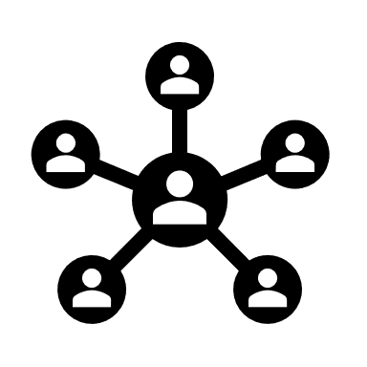
Mum

Home
Other
Dad

Brothers
Sisters

Friends and Family

School | L1  0 3 5 | L2  0 3 5 | L3  0 3 5
Communication  e.g. phone, emails, social media | L1  0 3 5 | L2  0 3 5 | L3  0 3 5
Reading | L1  0 3 5 | L2  0 3 5 | L3  0 3 5
Writing | L1  0 3 5 | L2  0 3 5 | L3  0 3 5
Language Proficiency

How easy do you find using your Languages :
0 Hard 3 OK 5 Easy

Speaking | L1  0 3 5 | L2  0 3 5 | L3  0 3 5
Listening | L1  0 3 5 | L2  0 3 5 | L3  0 3 5
Reading | L1  0 3 5 | L2  0 3 5 | L3  0 3 5
Writing | L1  0 3 5 | L2  0 3 5 | L3  0 3 5

